导论
- The system bus includes address bus, control bus and ( ) bus.
A.data B.character C.signal D.input
- Any program must be loaded into ( ) to be executed by the CPU.
- Disk B.Hard Disk C.Internal Storage D.External Storage
- The two main components of a computer are ( ).
Hint: Choose the most important option.
- Arithmetic unit and Controller B.Controllers and Registers
- Arithmetic and RAM D.Controller and RAM
- The decimal number 83 corresponds to the binary number ( ).
A.10011 B.1010011 C.1100101 D.1111101
- The basic structure of the algorithm does not include ( ).
- logical structure B.selective structure
- loop structure D.sequential structure
- The protocol used for sending and receiving E-mail on the Internet is ( ).
- TCP/IP B.IPX/SPX C.P0P3/SMTP D.NetBEUI
- The .MOV extension is usually a ( ) file.
- audio B.video C.picture D.text
- Which of the following is not a function of the operating system( )
- Manage the hardware and software resources of the computer.
- Organize computer workflow properly.
- Complete "translation" of high-level language programs.
- To provide users with convenient, effective and safe working environment.
- If the time slice of a time-sharing system is constant, then ( ), the longer the response time is.
- The fewer users B.The more users
C.The less memory D.The more memory

True/False
- A CPU is an integrated circuit. (True)
- We can divide the computer hardware devices into 4 basic categories:System unit,Input/Output devices,Secondary storage devices, and Communications devices. (True)
- The arithmetic logic unit(ALU) is only capable of performing basic arithmetic operations. (False)
- The steps of the Fetch-Execute Cycle are as follows: fetch the current instruction,decode the instruction,get data if needed,execute the instruction. (True)
- The von Neumann architecture is the underlying architecture of most of today`s computer,which has four parts: the control unit, the arithmetic/logic unit, memory, and input/output devices. (True)

Multiple choice
1.If the memory address space is 16 MB and the word size is 8 bits,then___ bits are needed to access each word.
A.8
B.16
C.24
D.32 (C)

2.The three steps in the running of a program on a computer are performed in this order: ______.
A.fetch,execute,and decode
B.decode,execute,and fetch
C.fetch,decode,and execute
D.decode,fetch,and execute (C)

- The____controller features a parallel interface and daisy-chained connection for I/O devices.
A.SCSI
B.FireWire
C.USB
D.IDE (A)

- Which optical storage device has the highest capacity?
A.CD-RAM
B.CD-R
C.CD-RW
D.DVD (D)

For exercises1-6, match the word or acronym with the definition or the appropriate blank
A. LAN
B. WAN
C. Gateway
D. Bus topology
E. Ethernet
F. Internet
1.the internet is a B___.
2.the industry standard for LAN. _E__.
3.A node that handles communication between its LAN and other networks.__C__
4. A network that connects other networks.F
5. Star topology is a A___ configuration.
6. Ethernet uses__D_.
- For Exercises 7-11,match the protocol or standard with what it specifies or defines.
A.SMTP
B.FTP
C.Telnet
D.HTTP
E.MIME type
7.Transfer of electronic mail A
8. Log in to a remote computer system.C
9. Transfer files to and from another computer.B
10. Format of email attachments.E
11. Exchange of World Wide Web documents.D
True/False
12. A port is a numeric designation that corresponds to a particular high-level protocol.T
13.A firewall protects a local-area network from physical damage.F
14. Each company can establish its own access control policy.T
15. Some top-level domains are based on the country in which the registering organization is based.T
16. Two organizations cannot have the same name for a computer.F

Question answering
What is a computer network?
A computer network is a collection of computing devices connected so that they can communicate and share resources.

What is a MAN and what makes it different from a LAN and a WAN?
A MAN is a metropolitan-area network. It is a network with some of the features of both a LAN and a WAN. Large metropolitan areas have special needs because of the volume of traffic. MANs are collections of smaller networks but are implemented using such techniques as running optical fiber cable through subway tunnels.

1. In a computer system, it is B that is at the bottom of the line that comes into direct contact with the hardware and supports other software
A language handler B operating system C utility D database management system
2. Computer software is generally divided into (system software) and (application software) by function
3.(True/False). A computer can have more than one operating system, but only one OS is in control at any given time. T
4. (True/False)A timesharing system allows multiple users to interact with a computer at the same time T
5. Explain the software lifecycle.
As with anything, a software product or software system has to go through the stages of incubation, birth, growth, maturity, and decay, commonly referred to as the software life cycle The software life cycle, also known as the software life cycle or system development life cycle, is the life cycle from the creation of software to its retirement
6. The earliest operating system, called ( A ) operating systems, only had to ensure that resources were transferred from one job to the next.
A. batch B. time-sharing C. personal D. parallel
7. DOS is considered a ( D ) operating system.
A. batch B. time-sharing C. parallel D. personal
8. The foundation of software engineering is (A).
A. Process B. Tool C. Design D. . Method
9. Which of the following is not the cause of the software crisis (B).
A. Subjective neglect of demand analysis
B. Over-emphasis is placed on software maintenance
C The wrong view of software development as programming
D. The software itself is a logical part, and it is getting bigger and bigger
10. The following software belongs to the application software (D).
A. Financial management software B. Database C. Compiler D. Browser

Multiple Choice
1．Which one of the following is NOT a step to change audio data to bit patterns?
a. Sampling b. Quantization c. Coding d. Curving

Filling in the blanks
1、A gray scale picture is digitized using 4 different gray levels. If the picture is composed of 100×100 pixels, 20000 (how many) bits are needed to represent the picture.

Open ended questions:
- Distinguish between computing as a tool and computing as a discipline.
- Is computing a mathematical discipline, a scientific discipline, or an engineering discipline? Why?
- Name and describe five subject areas of computer science.
- Explain in your own words why computers were invented and how they have been used.
- Explain computational thinking in your own words.
- Some people say computer science is mostly about programming, do you agree? Why?
- Some people say a computer can be compared to a human brain, do you agree? Why?
- What is more valuable to an organization: hardware, software, or data? Why?
- What are some limitations of computing?

硬件
一、简答题
1.按照冯·诺伊曼原理构成的计算机由哪几大部分组成？（冯诺依曼）
What are the major parts of a computer constructed according to the von Neumann principle?
运算器：完成各种算术运算和逻辑运算，是计算核心；
控制器：整个计算机的指挥控制中心；
存储器：实现“程序内存”思想的部件；
输入设备：将程序和原始数据转换为二进制串；
输出设备：将运算的结果转换为人们所能识别的信息形式。
Arithmetic unit: it completes various arithmetic operations and logical operations and is the core of calculation;
Controller: the command and control center of the entire computer;
Memory: the component that realizes the idea of "program memory";
Input device: Convert the program and the original data into a binary string;
Output device: Convert the result of the operation into a form of information that people can recognize.

2.计算机系统主要由什么组成？（同上）
What are the main components of a computer system?
中央处理器、存储器、输入输出控制系统和各种外部设备
Central processing unit, memory, input and output control system and various external equipment

3.多个程序共同运行时，计算机如何决定由谁运行？（CPU知识）
When multiple programs are running together, how does the computer decide who will run it?
结合计算机计算实现的过程及其核心（运算器）作答，答案合理即可
Combine the process of computer calculation and its core (computing unit) to answer, as long as the answer is reasonable

4. 冯诺依曼模型中输入/输出子系统的功能是什么？（输入输出设备知识）
What is the function of the input/output subsystem in the Von Neumann model?
标准答案为：输入设备将程序和原始数据转换成二进制串，并在控制器的指挥下按一定的地址顺序送入内存。输出设备则是用来将运算的结果转换为人们所能识别的信息形式，并在控制器的指挥下由机器内部输出，实际答案合理即可
The standard answer is: the input device converts the program and the original data into a binary string, and sends it to the memory in a certain address sequence under the command of the controller. The output device is used to convert the result of the calculation into a form of information that people can recognize, and output from the machine under the command of the controller. The actual answer is reasonable.
5.简述RAM和ROM的区别。（存储器知识）
Briefly describe the difference between RAM and ROM.
RAM断电后的内容全部丢失，既可以读又可以写，速度比Cache慢，而RAM可分为表态RAM（SRAM）和动态RAM（DRAM）两种。
ROM计算机运行时其内容只能读出而不能写入。数据不易丢失，即使计算机断电后 ROM存储单元的内容依然保存。只读存储器一般存储计算机系统中固定的程序和数据，如引导程序、监控程序等。
All the contents of RAM are lost when the power is off. Both can be read and written, and the speed is slower than Cache. RAM can be divided into two types: static RAM (SRAM) and dynamic RAM (DRAM).
When the computer is running, ROM’s content can only be read but not written. Data is not easy to lose, even if the computer is powered off, the content of the ROM storage unit is still preserved. Read-only memory generally stores preset programs and data in the computer system, such as boot programs, monitoring programs, and so on.

6.为什么要增加 Cache（存储器知识）
Why increase Cache
由于CPU工作的速度比RAM读写速度快，CPU读写RAM时需要花费时间等待 RAM进行读写，造成CPU工作速度下降。为了提高CPU读写程序和数据的速度，在RAM和CPU之间增加了高速缓存部件。
As the CPU works faster than the RAM read and write speed, it takes time to wait for the RAM to read and write when the CPU reads and writes the RAM, which causes the CPU work speed to drop. In order to increase the speed of the CPU to read and write programs and data, a cache component is added between the RAM and the CPU.

7. Cache有什么特点（存储器知识）
What are the characteristics of Cache
Cache的特点是：读写速度快、存储容量小、价格高、断电后内容丢失。
The characteristics of Cache are: fast read and write speed, small storage capacity, high price, and volatile.

8.如果要组装一台微机，你需要准备哪些组件？
If you want to assemble a microcomputer, what components do you need to prepare?
主板、CPU、内存、机箱、电源、显卡、声卡、显示器、键盘、鼠标。
Motherboard, CPU, memory, chassis, power supply, graphics card, sound card, monitor, keyboard, mouse.
9.简要解释bit和Byte的概念（冯诺依曼）
Briefly explain the concepts of bit and Byte
bit是计算机中最小的信息单位，也就是一个二进制位。一个位能储存一个二进制数，称为1b
Byte是计算机度量存储容量的计量单位。8个相邻的位组成一组称为一个字节（Byte）
A bit is the smallest unit of information in a computer, that is, a binary bit. A bit can store a binary number, called 1b
Byte is a unit of measurement used by computers to measure storage capacity. A group of 8 adjacent bits is called a byte (Byte)

10.列举除键盘鼠标外的3种输入设备。（输入输出设备知识）
In addition to keyboard and mouse, there are roughly four types of input devices，what are they?
光学阅读设备、图形输入设备、头像输入设备、模拟输入设备。
Optical reading device, graphic input device, avatar input device, analog input device.
扫描仪、数码相机、麦克风
Scanner, digital camera, microphone

11.总线的技术指标有哪些？（总线知识）
What are the technical indicators of the bus?
总线带宽、总线位宽、总线频率
Bus bandwidth, bus bit width, bus frequency

12.计算机的控制器由哪五个重要部分组成？（CPU知识）
What are the five important parts of a computer controller?
指令寄存器、程序计数器、操作控制器、地址生成部件、时序电路
Instruction register, program counter, operation controller, address generation unit, sequential circuit

13.中文房间：（硬件综合）
这是由美国哲学家John Searle提出的一个思想实验，旨在推翻图灵测试这一强人工智能测试提出的过强主张。
这个实验要求想象一位只会说英文的人身处在一个近似密闭的房间中，这个房间除了门上的一扇用于传递纸片的小窗户外全部都是封闭的。在房间里有一本带有中文翻译程序的手册以及其他稿纸铅笔等足够帮助他翻译的东西。根据searle的描述，房间里的人可以根据那本手册来翻译传入屋中的中文文字并且用中文回答。虽然他完全不会中文，但是他却可以让任何房间外的人误以为他会说中文。
请结合材料简述中文房间案例对我们的启示。
Chinese Room:
This is a thought experiment proposed by the American philosopher John Searle, aimed at overthrowing the strong proposition put forward by the Turing Test, a strong artificial intelligence test.
This experiment requires to imagine that a person who only speaks English is in an approximately closed room, which is closed except for a small window on the door for passing paper. In the room there is a manual with a Chinese translation program and other manuscript paper and pencils enough to help him translate. According to Searle’s description, the people in the room can translate the Chinese text in the house according to the manual and answer in Chinese. Although he can't speak Chinese at all, he can make anyone outside the room mistakenly think that he can speak Chinese.
Please briefly describe the enlightenment of the Chinese room case to us in combination with the materials.
只要计算机拥有了适当的程序，理论上就可以说计算机拥有了它自己的认知状态并且可以像人一样地进行理解活动。电脑无法真正理解接收到的信息，但它们可以运行一个程序，以此来处理信息，然后给人一个智能的印象。（结合材料，意思相近即可）
As long as the computer has the appropriate program, it can theoretically be said that the computer has its own cognitive state and can perform comprehension activities just like humans. Computers cannot really understand the received information, but they can run a program to process the information, and then give people an intelligent impression. (Combining materials, as long as the meaning is similar)

14.请简要介绍什么是图灵测试？（计算机思维）
What is the Turing test?
指测试者与被测试者（一个人和一台机器）隔开的情况下，通过一些装置（如键盘）向被测试者随意提问。进行多次测试后，如果机器让平均每个参与者做出超过30%的误判，那么这台机器就通过了测试，并被认为具有人类智能。答案合理即可
It refers to the situation where the tester is separated from the testee (a person and a machine), using some devices (such as a keyboard) to ask questions to the testee at will. After many tests, if the machine makes each participant make more than 30% false judgments, then the machine has passed the test and is considered to be human-intelligent.(As long as the answer is reasonable.)

15. 1997年，美国纽约曼哈顿一幢高楼里曾进行过一场被媒体称为“人机大战”的国际象棋比赛。对局的一方是1985年以来一直独霸棋坛的俄罗斯棋王卡萨帕罗夫，另一方是美国IBM公司推出的“天下第一”下棋机器-名为“深蓝”的超级计算机。尽管卡萨帕罗夫一开始就声称他是“为尊严而战”，但最后“深蓝”还是以3.5：2.5的总比分取胜。对此，世界舆论一片哗然。
机器能不能思维？这不仅是一个科学命题，而且是一个哲学命题。“深蓝”于1996年已经和卡萨帕罗夫交过一次手，结果以1胜2平3负失败。随后IBM的专家们一方面努力从硬件上提高“深蓝”的运算能力和速度，另一方面加深“深蓝”对棋局的“理解”，终于使其棋力大增，最后战胜棋王。难怪卡萨帕罗夫在赛后说，这次比赛“是一群人运用计算机来向一个人的智慧和反应挑战”。
根据以上描述，请解释卡萨帕罗夫赛后说的那句话的含义。从你个人的理解阐述“深蓝”为什么会赢。（计算机思维）
In 1997, a high-rise building in Manhattan, New York, USA once had a chess game called "Man-machine War" by the media. One side of the game is the Russian chess king Kasaparov, who has dominated the chess world since 1985, and the other is the "world first" chess machine-a supercomputer called "Deep Blue" launched by IBM. Although Kasaparov claimed at the beginning that he was "fighting for dignity", in the end "Deep Blue" won with a total score of 3.5:2.5. In response, world public opinion was in an uproar.
Can machines think? This is not only a scientific proposition, but also a philosophical proposition. "Deep Blue" had already fought with Kasaparov in 1996, but failed with 1 win, 2 draws and 3 losses. Subsequently, IBM experts worked hard to improve "Deep Blue"'s computing power and speed from the hardware, on the other hand, deepened "Deep Blue"'s "understanding" of the chess game, and finally increased its chess power and finally defeated the chess king. No wonder Kasaparov said after the game that this game "is a group of people using computers to challenge one's intelligence and response."
Based on the above description, please explain the meaning of what Kasaparov said after the game. Explain why "Deep Blue" will win from your personal understanding.
结合材料中提到的“运算能力”、“速度”等简要解释计算机的工作原理，发展前景即可。
Briefly explain the working principle of the computer in combination with the "calculation ability" and "speed" mentioned in the material, and the development prospects are enough.

二、单选题
1.微型计算机的核心部件是（ )。（CPU知识）
A.微处理器 B.控制器
C.存储器 D.运算器
The core component of the microcomputer is ().
A. Microprocessor B. Controller
C. Memory D. Operator

2.在微机主板上，用于为CPU等设备提供服务的是【】。（总线、主板知识）
A南桥芯片组
B北桥芯片组
C系统总线
D扩展插槽
On the microcomputer motherboard, it is used to provide services for CPU and other equipment is [].
A South Bridge Chipset
B North Bridge Chipset
C system bus
D expansion slot

4．组成计算机的CPU的两大部件是（ ）。（CPU知识）
A．运算器和控制器
B. 控制器和寄存器
C．运算器和内存
D. 控制器和内存
The two major components of a computer's CPU are ().
A. Arithmetic unit and controller
B. Controller and registers
C. Arithmetic unit and memory
D. Controller and memory

5. 在冯诺依曼模型中，______子系统作为其他子系统的管理者。（冯诺依曼）
A. ALU
B. 输入/输出
C..内存
D.控制单元
In the von Neumann model, the ______ subsystem acts as the manager of other subsystems.
A. ALU
B. Input/Output
C: Memory
D. Control unit

7.如果E的ASCII码是1000101，那么e的ASCII码是___
A. 1000110
B.1000111
C. 0000110
D. 1100101
If the ASCII code of E is 1000101, then the ASCII code of e is ______
A. 1000110
B.1000111
C. 0000110
D. 1100101

8．下列说法中，不正确的是（)。（CPU知识）
A）时钟频率对CPU的性能没有影响
B）协处理器可以作为独立的器件添加到计算机系统中
C）字长取决于寄存器的长度和总线的宽度
D）多核计算机比单核计算机的计算能力强
Among the following statements, the incorrect one is ().
A) The clock frequency has no effect on the performance of the CPU
B) The coprocessor can be added to the computer system as an independent device
C) The word length depends on the length of the register and the width of the bus
D) Multi-core computers have stronger computing power than single-core computers

9．下面4条常用术语的叙述中，有错误的是（)。（存储器知识，总线知识，内存知识）
A）计算机的硬件平台至少要包含主机和支持应用所必需的外部设备
B）读写磁头是既能从磁表面存储器读出信息又能把信息写入磁表面存储器的装置
C）总线是计算机系统中各部件之间传输信息的公共通路
D）计算机的硬件计算环境最主要的是内存容量
In the description of the following 4 commonly used terms, which one is mistaken?().
A) The hardware platform of the computer must at least include the host computer and the peripheral equipment necessary to support the application
B) The read-write head is a device that can read information from and write information into the magnetic surface memory
C) The bus is a common channel for transmitting information between various components in the computer system
D) The most important thing in the computer's hardware computing environment is the memory capacity

10.下列关于总线的说法中，错误的是（)。（总线知识）
A）ISA、PCI和USB都是扩展总线
B）总线一次能传送的比特数目称为总线宽度
C）系统总线是指CPU与各外部设备连接的总线
D）总线的类型分为内部总线、系统总线和扩展总线
Among the following statements about the bus, the error is ().
A) ISA, PCI and USB are all expansion buses
B) The number of bits that the bus can transmit at one time is called the bus width
C) The system bus refers to the bus that connects the CPU to various external devices
D) The type of bus is divided into internal bus, system bus and expansion bus

11. 冯•诺依曼提出 3 个重要思想，除了计算机基本结构外，还有（） （导论知识）
A) 采用二进制和内存储器的概念
B) 采用机器语言和二进制
C) 采用二进制和存储程序控制的概念
D) 采用 ASCII 编码和二进制
Von Neumann put forward three important ideas, in addition to the basic structure of the computer, there are ()
A) Adopt the concept of binary and internal memory
B) Using machine language and binary
C) Adopt the concept of binary and stored program control
D) Adopt ASCII encoding and binary

12. 计算机的内存储器由()组成 （存储器知识）
A) RAM
B) ROM
C) RAM 和硬盘
D) RAM 和 ROM
The computer's internal memory is composed of ()
A) RAM
B) ROM
C) RAM and hard disk
D) RAM and ROM

13. 使用Cache可以提高计算机运行速度，这是因为_____。 （存储器知识）
A. Cache增大了内存的容量 B. Cache扩大了硬盘的容量
C. Cache缩短了CPU的等待时间 D. Cache可以存放程序和数据
Using Cache can increase the speed of the computer, this is because _____.
A. Cache increases the capacity of the memory B. Cache increases the capacity of the hard disk
C. Cache shortens the waiting time of the CPU D. Cache can store programs and data

14．在下列设备中，属于输出设备的是(D)。（输入输出设备知识）
A)硬盘 B)键盘 C)鼠标 D)打印机
Among the following devices, the one that belongs to the output device is (D).
A) Hard disk B) Keyboard C) Mouse D) Printer

185 断电会使原存信息丢失的存储器是____。（存储器知识）
A. RAM B. 硬盘 C. ROM D. 软盘
The memory that will lose the original information when the power is off is ____.
A. RAM B. Hard disk C. ROM D. Floppy disk

16. I/O接口位于_____。 （接口知识）
A.主机和I/O设备之间 B.主机和总线之间
C.总线和I/O设备之间 D. CPU与存储器之间
The I/O interface is located at _____.
A. Between host and I/O device B. Between host and bus
C. Between bus and I/O device D. Between CPU and memory

17. 在计算机运行时，把程序和数据一样存放在内存中，这是1946年由_____领导的研究小组正式提出并论证的。（导论组知识）
A．图灵 B.布尔
C．冯·诺依曼 D.爱因斯坦
When the computer is running, the program and data are stored in the memory. This was formally proposed and demonstrated by the research team led by _____ in 1946.
A. Turing B. Boolean
C. Von Neumann D. Einstein

18. 在下面关于计算机系统硬件的说法中，不正确的是_____。 （存储器知识）
A. CPU主要由运算器、控制器和寄存器组成
B．当关闭计算机电源后，RAM中的程序和数据就消失了
C. 软盘和硬盘上的数据均可由CPU直接存取
D．软盘和硬盘驱动器既属于输入设备，又属于输出设备
In the following statements about computer system hardware, what is incorrect is _____.
A. The CPU is mainly composed of arithmetic units, controllers and registers
B. When the computer is turned off, the programs and data in RAM disappear
C. The data on the floppy disk and hard disk can be directly accessed by the CPU
D. Floppy disks and hard drives are both input devices and output devices

19．下列有关存储器读写速度的排列，正确的是_____。 （存储器知识）
A. RAM>Cache>硬盘>软盘
B．Cache>RAM>硬盘>软盘
C. Cache>硬盘>RAM>软盘
D. RAM>硬盘>软盘>Cache
The following arrangement about the read and write speed of the memory, which is correct is _____.
A. RAM>Cache>Hard Disk>Floppy Disk
B. Cache>RAM>Hard Disk>Floppy Disk
C. Cache>hard disk>RAM>floppy disk
D. RAM>Hard Disk>Floppy Disk>Cache

20、关于硬件系统和软件系统的概念，下列叙述不正确的是（）（硬件和软件的知识衔接）
A 计算机硬件系统的基本功能是接受计算机程序，并在程序控制下完成数据输入和数据输出任务
B 软件系统建立在硬件系统的基础上，它使硬件功能得以充分发挥，并为用户提供一个操作方便、工作轻松的环境
C 没有装配软件系统的计算机不能做任何工作，没有实际的使用价值
D 一台计算机只要装入系统软件后，即可进行文字处理或数据处理工作
Regarding the concept of hardware system and software system, which of the following statements is incorrect is ()
A The basic function of a computer hardware system is to accept computer programs and complete data input and data output tasks under the control of the program
B The software system is established on the basis of the hardware system, which enables the hardware functions to be fully utilized, and provides users with an environment that is easy to operate and work easily
C A computer without a software system cannot do any work and has no actual use value
D A computer can be used for word processing or data processing as long as it is loaded into the system software

三、判断题
1.存储程序控制原理是冯·诺依曼思想的核心。（T) （冯诺依曼）
The principle of stored program control is the core of von Neumann's thought. ()

3．GPU使显卡减少了对CPU的依赖，并承担部分原本CPU的工作，尤其是在进行3D图形处理时。（T)（GPU知识）
The GPU enables the graphics card to reduce the dependence on the CPU and undertake part of the original CPU work, especially when performing 3D graphics processing. ()

4．一台微型计算机就是以CPU为核心，其他部件全“挂接”在与CPU 相连接的系统总线上。（ T )（总线知识）
A microcomputer is based on the CPU, and other components are all "connected" to the system bus connected to the CPU. ()

5．协处理器也是一种芯片，用于减轻系统微处理器的特定处理任务。（T）（CPU知识）
The coprocessor is also a kind of chip, which is used to reduce the specific processing tasks of the system microprocessor. ()

6．存储器的主要功能是存储当前使用的程序和数据。（ T)（存储器知识）
The main function of the memory is to store currently used programs and data. ()

10．Cache是外存储器。（F )（存储器知识）
Cache is external storage. ()

11．打印机的主要技术指标是印刷质量、速度和噪声。（ T）（输入输出设备知识）
The main technical indicators of the printer are printing quality, speed and noise. ()

12．决定计算机运算速度的因素之一是每秒钟能执行指令的条数。（T )（CPU知识）
One factor that determines the computing speed of a computer is the number of instructions that can be executed per second. ()

13．只读存储器是专门用来读出内容的存储器，但在每次加电开机前，必须由系统为它写入内容。（F )（存储器知识）
Read-only memory is a memory specially used to read content, but the system must write content for it before powering on each time. ()

四、填空题
1.CPU的主要生产厂商是_____AMD _____和____Intel____公司。（CPU知识）
The main manufacturers of CPU are __________ and ______ companies.

3．天文、军事、仿真、科学计算等领域需要进行大量的计算，要求计算机有更高的运算速度、更大的存储容量，这就需要研制功能更强的__超级计算机__（计算机常识）
Astronomy, military, simulation, scientific computing and other fields need to perform a lot of calculations, requiring computers to have higher computing speeds and larger storage capacity, which requires the development of more powerful __supercomputers__

5．RAM技术可分为__SRAM/DRAM____两大类。（存储器知识）
RAM technology can be divided into two categories: ______.

6．ALU主要用于进行__算术___运算和__逻辑___运算。（CPU知识）
ALU is mainly used for_arithmetic operations_____ and_logical operations__.

7．中央处理器（CPU）由算术逻辑单元、__控制单元__、__寄存器组___三部分组成。（CPU知识）
The central processing unit (CPU) is composed of three parts: arithmetic logic unit, __ Control unit__ and ___registers ___.

8．微型计算机的主板上安装的主要部件有处理器 、内存、处理输入输出的芯片和些扩展槽。（主板知识）
The main components installed on the motherboard of the microcomputer are CPU, memory, chips for processing input and output and some expansion slots.

9．衡量微型计算机的主要技术指标是___字长___、主频、内存容量、可靠性和可用性五项指标。（）
The main technical indicators for measuring microcomputers are five indicators: ____word size___, main frequency, memory capacity, reliability and availability.

10．现在主导市场的两种计算机基本设计是___复杂指令集计算机___和精简指令集计算机。（CPU知识（架构））
The two basic designs of computers that currently dominate the market are ____CISC(Complex……)____and reduced instruction set computers.

11．在微型计算机中，内存是按__字节___编址的。（内存知识）
In a microcomputer, the memory is addressed by ___Bytes___.

12．单元地址是指___存储单元____的地址编号。（存储器知识）
The unit address refers to the address number of___ Storage unit___.

13．在微型计算机中，I／O设备是指 输入输出设备。（输入输出设备知识）
In microcomputers, I/O refers to .

14．早期的Pentium微处理器是准64位，其意思是_外部数据总线__为32位，__内部数据总线__为64位。（CPU知识）
Early Pentium microprocessors were quasi-64 bits, which meant__ External data bus __ is 32 bits and___ internal data bus
__ is 64 bits.

15．如果某存储器芯片共有20根地址线的引脚，则该存储器芯片的存储容量为__1MB___（存储器知识）
If a memory chip has a total of 20 address line pins, the storage capacity of the memory chip is____

18．高速缓冲存储器位于内存储器和___ CPU___之间。（存储器知识）
The cache memory is located between the internal memory and__ CPU____.

19.计算机执行程序的过程，实际上是反复进行取指令、___分析指令（或译码）__、和执行指令的过程（CPU知识）
The process of the computer executing the program is actually the process of repeatedly fetching instructions, ____analyzing instructions (or decoding instructions) __, and executing instructions

20.图灵机由一条无限长的纸带、一个读写磁头、一个____状态寄存器____和一套控制规则组成。（计算机发展知识）
The Turing machine is composed of an infinite length of paper tape, a read-write head, a status register, and a set of control rules.

True/False
1、USB port can be used to connect printers.（T）

Multiple Choice
1. Which one of the following represents the largest capacity?
a. 2³⁵ KB b. 1024 MB c. 1 TB d. 100 GB
2.下列对计算机按尺寸从大到小的排列正确的是：(A) （此题由软件组提供）
a. mainframe b. microcomputer c. minicomputer d. super computer
A. dacb B. adcb C. acbd
The following computers are arranged correctly by size from large to small:(A).
a. mainframe b. microcomputer c. minicomputer d. super computer
A. dacb B. adcb C. acbd

Filling in the blanks
- CPU speed is influenced by several factors including clock rate, word size , cache, and instruction set size.
- In the last step of the booting process, the operating system loads system configuration information, which, in Windows, is contained in several files called registry（注册表） .
- An imaginary computer has four data registers (R0 to R3), 1024 words in memory, and 16 different instructions (add, subtract, etc.). The minimum size of an instruction in bits if a typical instruction uses the following format is 16 : add 565 R2
- There are different types of registers inside a CPU, including data registers,
instruction registers（指令寄存器） and program counter.

Question answering（本部分题目由软件组提供）
1.总线包括哪几种，各自的作用是什么？
<1系统总线：用来在CPU与主存储器，IO接口之间传送信息
<2外部总线：用来连接计算机与外部设备
<3内部总线：用来连接芯片内部的各个原件
What are the bus types and what are their respective roles?
<1 System Bus: Used to transfer information between the CPU and the primary memory, IO interface
<2 External Bus: Used to connect your computer to an external device
<3 Internal Bus: Used to connect individual originals inside the chip

2.系统总线包括哪几种，各自的作用是什么？
<1数据总线：CPU与主存储器和IO设备之间传送数据
<2地址总线：给出数据所在的存储单元的地址
<3控制总线：控制地址总线和数据总线的访问和使用
What are the system buses and what are their respective roles?
<1 Data Bus: Transfer data betweenthe CPU and the primary memory and IO devices
<2 Address Bus: Gives the address of the storage unit where the data is located
<3 Control Bus: Controls access and use of address bus and data bus

3．请简要概述冯诺依曼原理的主要思想：
<1采用二进制
<2把数据和指令都存放在存储器中
<3计算机的五大部件：输入设备，输出设备，存储器，运算器，控制器
Please briefly outline the main ideas of the von Neumann principle:
<1 use binary systems
<2 stores both data and instructions in memory
< 3 The five components of a computer: input device, output device, memory, ALU, controller

Open ended questions
1、Explain in your own words the idea of storage hierarchy.
2、Explain how CPU works by using the following illustration.
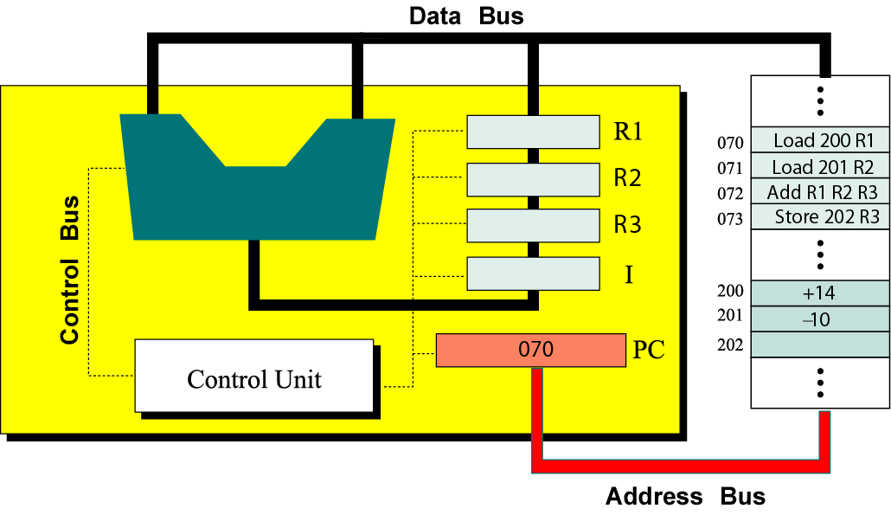
- Explain the Stored-Program Concept.
- Describe the booting process for a PC running Windows.
- How would you troubleshoot your laptop computer if it is not working properly. What is the rationale behind your decisions? (Why would you do those things?)
- Which one of the following laptop do you prefer? Why?
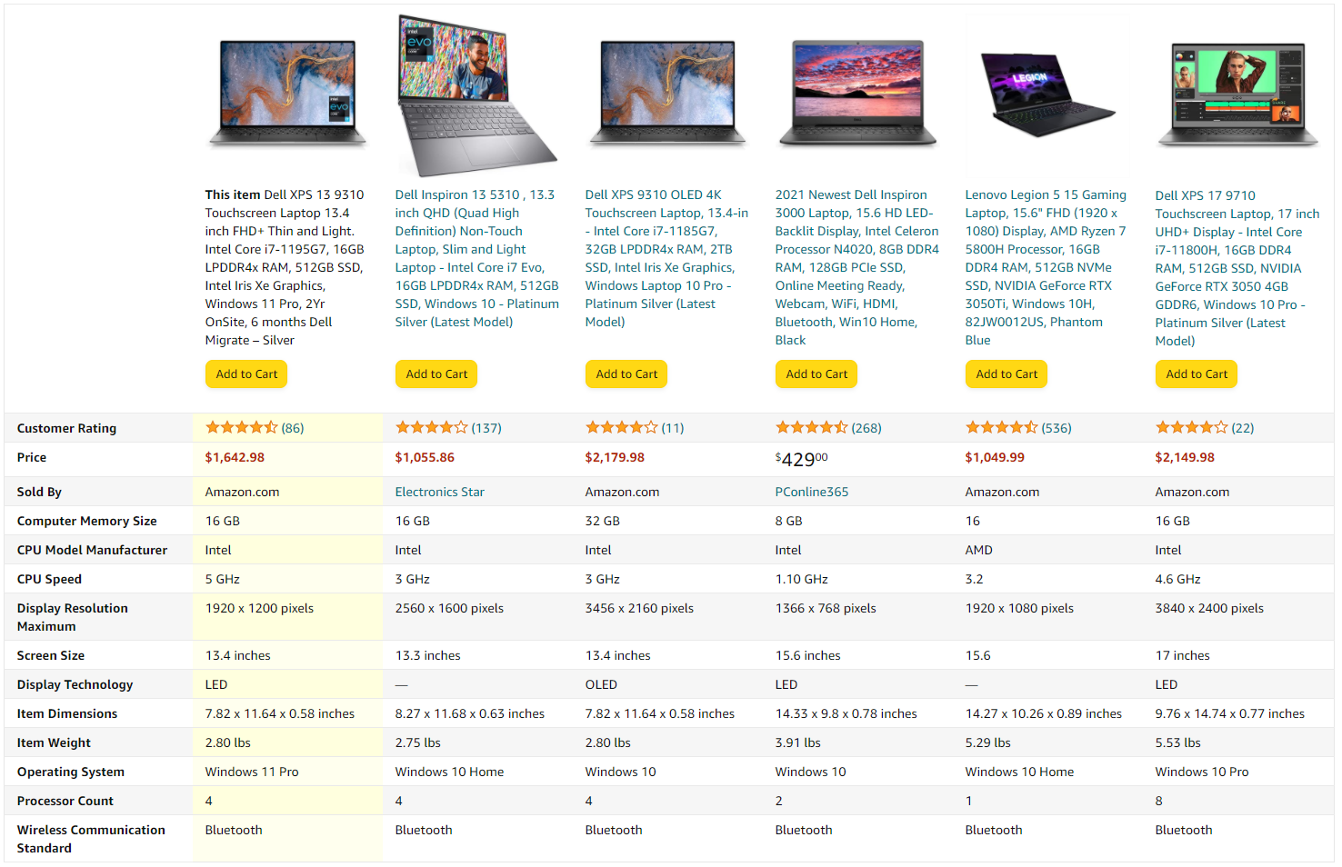

软件
填空题（Fill in the blanks）
1、位图通常需要更（大）的存储空间。
A bitmap image usually requires more (larger) storage space.
2、（位）图被分成一个个矩阵像素点，其中白色用1来表示，黑色用0表示。
A bitmap is divided into matrix pixels, where white is represented by 1 and black is represented by 0.
3、（矢量）图由一个个直线方程和曲线方程构成。
The vector image consists of linear equations and curve equations.
4、视频是由一帧帧的（位）图组成的。
Video is a representation of images (called frames ) over time.
5、ASCII码中每一个symbol用（7或8）个比特位来定义.
Each symbol in the ASCII code is defined by 7 or 8 bits.
6、在软件的生命周期中，我们在（设计）阶段去将需求转化为可以实现的技术方案。
In （design）stage, we turn our requirements into realizable technology plan during the system life cycle.
7.对于一个signed integers （n位）它的补码的范围是
-（2的n-1次方）~2的n-1次方-1
For a signed integer (n bits), the range is
.-(2 to the (n-1)th) to 2 to the (n-1)th-1

判断题（True or False）
- 数据总线的宽度就是数据总线的根数，它决定着能同时传输的信息位数。（T）
The width of the data bus is the number of lines of the data bus, which determines the number of bits that can be transmitted at the same time.（T）
- 地址总线决定着CPU的寻址能力，若用N位的地址总线，则可寻空间是2的N次方(T)
The address bus determines the addressing capability of the CPU, and if you use the address bus for N bits, the accessible space is 2 to the n-th. (T)
- 软件分为系统软件和应用软件（T）
Software is divided into system software and application software(T)
- 操作系统是只能读不能写的软件，存储在ROM中。（F）
The operating system is software that can only be read and cannot be written and stored in the ROM. （F）
- 软件设计要尽量避免“模块化” （F）
Software design should avoid modularity (F)
- 在软件设计的过程中可能会使用到UML和structure chart 和 class diagram（T）
UML, structure chart and class diagrams may be used during software design.(T)
- 在软件设计的过程中，各个模块之间要有有一定的独立性，即不能任意地互相访问对方的信息。（T）
Information shielding between modules in the software design process means that each other's information cannot be accessed arbitrarily. （T）
- 在软件实现的过程中要尽量避免使用pseudocode而要采用某一种具体的语言去编写（F）
In the process of software implementation, try to avoid using pseudocode and write in a specific language (F)
- signed integers的最高位通常用0表负数（F）
Signed integers typically uses the first 0 to mean negative numbers.(F)
- 对于正数来说，原码反码和补码都是同一个二进制数。（T）
For positive numbers, we use the same bit patterns for a number no matter which of the following scheme we use: sign-and-magnitude, one’s complement, and two’s complement. （T）
- 对一个数的补码再求补码得到的一定是这个数字的原值。（T）
If we two’s complement a number twice, we get the original number. （T）
- Java有很快的运行速度并且可以借助“指针”去解决问题。(F)
Java has fast speed and can solve problems with the help of pointers. (F)
- 瀑布模型适合去解决变化性强且无确定需求的问题。（F）
Waterfall model is useful for dealing with problems which change frequently and have no concrete requirements. （F）
- 设备驱动软件属于系统软件（T）
The system software includes device drivers.（T）
- 文字处理软件和电子表格制作软件都属于系统软件（F）
Word process software and spreadsheet software both belong to system software.(F)
16.用户界面分为commandline和GUI（graphical users interface）两种，dos属于后者。（F）
There are two interfaces:command line user interfaces and graphical interfaces.DOS uses the latter.(F)
17.桌面图标是commandline interface的标志。（F）
icons will appear in the commandline interface(F)
18.monoprogramming是单道程序处理.CPU利用率更高（F）
The efficiency of Monoprogramming is higher than multiprogramming.(F)
19.在多道程序处理系统中，process manager在处理queuing的时候总是先执行最短的指令。（F）
In a multiprogramming system, the process manager always executes the shortest instruction before processing the queue.（F）

单选题（multiple choice）

1.下列不属于操作系统的功能的一项是（D）：
A. provide uses interface
B. run the applications
C. manage resources and files
D. compress audio and video data
Which one is not the function of an operating system(D):
A. provide uses interface
B. run the applications
C. manage resources and files
D. compress audio and video data

2.下列不属于系统软件的一项是：
A.操作系统 B.编译器 C.输入输出设备驱动器 D.视频软件
One of the following is not part of the system software:
- Operating system B. Compiler C. Input and output device drive D. Video software

3．下列哪一项是要在需求分析的过程中使用到的？（A）
A.数据流图和数据字典 B.软件管理日志 C.维护日志 D.设计日志
Which of the following is to be used in the requirements analysis process? （A）
A. Data flow diagrams and data dictionaries
B. Software management log
C. Maintenance logs
D. Design logs

4.下列哪一项符合软件设计的要求？(A)
A. high cohesion low coupling
B. low cohesion high coupling
C. high cohesion high coupling
D. low cohesion low coupling

Which of the following meets the requirements of software design? (A)
A. high cohesion low coupling
B. low cohesion high coupling
C. high cohesion high coupling
D. low cohesion low coupling

5.程序员的个人能力最会影响到下列的哪一种测试的质量？（A）
A. 白盒测试 B. 黑盒测试 C. 动态测试 D. Alpha测试
Which of the following tests is affected the most by the programmer's personal ability:（A）
A. White box test B. black box test C. dynamic test D. Alpha test

6.flow chart 一般在软件开发的哪一个环节用？（A）
A. 实现
B. 测试
C. 设计
D. 需求
Flow chart is generally used in which stage of software development? （A）
A. Implementation
B. Testing
C. Design
D. Requirement

排序题（Put these steps in a correct order）
1.假如你想要制作一款类似于“王者荣耀”的游戏，你应该如何做？请将下列的步骤按正确的顺序排列：AEDCB
- 分析
- 运营和维护
- 测试
- 实施（编程）
- 设计
If you want to make a game just like The King of Glory, how can you do it? Please put these steps in correct order: AEDCB
A. analysis
B. operations and maintenance
C. testing
D. coding
E. designing

2.请根据时间顺序排列操作系统的发展历程（A F E D B C）
Order the following OS technologies. （A F E D B C）
A.No operating system
B.parallel system
C.distributed system
D.personal system
E.time sharing system
F.batch system

问答题（Question answering）

1、说出你知道的程序设计语言的发展阶段：
<1机器语言
<2汇编语言
<3高级语言
<4非过程化语言
List the evolution of programming languages:
< 1 machine language
<2 assembly language
< 3 high-level languages
<4 non-procedural language

2.操作系统由哪四部分组成（四个管理）（What are the four parts of the operating system (four management) ）
<1file management
<2memory management
<3process management
<4device management

3.请简要的描述软件的设计分析流程：
<1可行性研究
<2需求分析
<3概要设计
<4详细设计
<5实现
<6测试
<7使用
<8维护
<9退役
Please briefly describe the software development life cycle:
<1 feasibility research
<2 requirements analysis
<3 preliminary design
<4 detailed design
<5 implementation
<6 testing
<7 use
<8 maintenance
<9 retiring

4.C语言的特点有什么？请至少举出三条。（合理即可）
<1>占用资源少
<2>学习难度大
<3> 速度快
<4>适合嵌入式开发
……
what are the features of C language? please list at least 3 features. （Anything reasonable is ok）
<1>take up less resources
<2>hard to learn
<3>fast speed
<4> suitable for embedded development
……

5.软件的生命周期和软件的开发模型一样吗？请举出例子并说明理由。（合理即可）
Is the system life cycle the same as the development process models? Please list some examples and explain. （Anything reasonable is ok）
二者并不一样。
软件的生命周期是一个软件产品或软件系统从孕育、诞生、成长、成熟到最终衰亡的全部过程。其中的阶段有很多，例如：设计，测试等
而软件开发模型则是一种面对实际去解决问题的方法，在不同的场景去采用不同的方法解决问题，有着多元化的特点。例如：瀑布模型、增量模型等
举个例子：生命周期，就好像你人有生老病死一样，这是一个跟具体哪个人没有太大关系，只跟你是“人”这种类型的生物有关系的东西。就像软件生命周期，跟你具体是哪款、哪类、哪家公司开发的软件没有关系，只要你是“软件”这种类型的东西，就有相同或相似的生命周期。
而软件开发过程模型，就好像人生模式和人生的关系。同样是一次人生，你可以单身过，也可以儿孙满堂地过。不同的人选择不同的人生模式。就和对于不同的软件或者不同公司的软件，可以采取不同的软件开发过程模型来开发一样。
They are different.
System life cycle is the whole process of a software product or software system from conception, birth, growth, maturity to final decline. There are so many stages , such as, designing stage, testing stage and so on.
The development process model is a practical method to solve problems. It adopts different methods to solve problems in different scenarios. There are different models such as, waterfall model, incremental model and so on.

连线题（Matching）
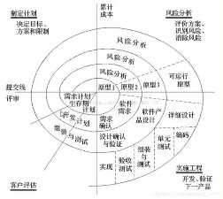
将流程图和相应的模型连线（match the flow charts with the corresponding models）
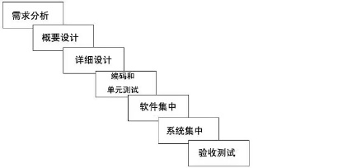
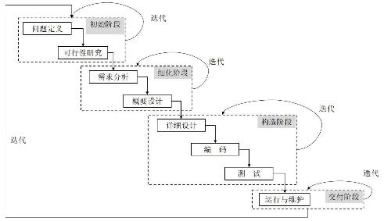
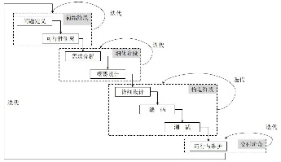

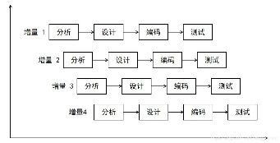
1 2 3
4
- 瀑布模型-Waterfall model;
- 增量模型-Incremental model;
- 螺旋模型-Spiral model;
- 迭代模型-Iterative model
Answer:1—C;2—D;3—A;4—B

True/False
1、There are two 0s in two's complement representation: positive zero (+0) and negative zero (-0).（F）
2、Vector images usually use much less storage space than bitmap images, but do not look as realistic as bitmap images.（T）
3、Demand paging and segmentation is a swapping memory management technique. （T）
4、Starvation can happen when the operating system puts too few （太少）resource restrictions on a process.（F）
5、In an operating system, the file manager is responsible for access to I/O devices.（F）

Filling in the blanks
1、The development process in the software life cycle involves 4 phases: analysis, design, implementation, and testing .

Open ended questions
- Explain in your own words how programming languages evolved.
- Describe how memory management in operating system evolved.
- What are the key issues we need to consider when it comes to process management (in operating systems).
- Why process synchronization is a big issue in process management?
- What are the main functions of operating systems? Use any one of the following popular OS to explain: Windows/Android/iOS/Linux.
- Tell the difference between software and program.
- Explain some of the key ideas of software engineering.
- Why are there so many different software development models/development process models?
- Compare two software development models/development process models that you’re familiar with.
- Define software quality in your own words. (What are the factors we need to consider when it comes to software quality?)

算法
Test materials（算法与数据结构部分）
- Fill-in-the-blanks test
  - What’s the time complexity of this program___O(n^2)_____
for( int i=1;i<=n;i++)
for( int j=1;j<= m; j++)
A[i][j] = i*j ;

  - What’s the time complexity of this program?_____O(n^3)___
int a = 0;
scanf("%d", &a);
for (int i = a; i < a + 4; i++)
{
int count = 0;
for (int j = a; j < a + 4; j++)
{
for (int k = a; k < a + 4; k++)
{
if (i != j && j != k && i != k)
{
count++;
printf("%d%d%d", i, j, k);
if (count != 6) printf(" ");
}
}
}
printf("\n");
}

  - What’s the time complexity of select sort?____O(n^2)____
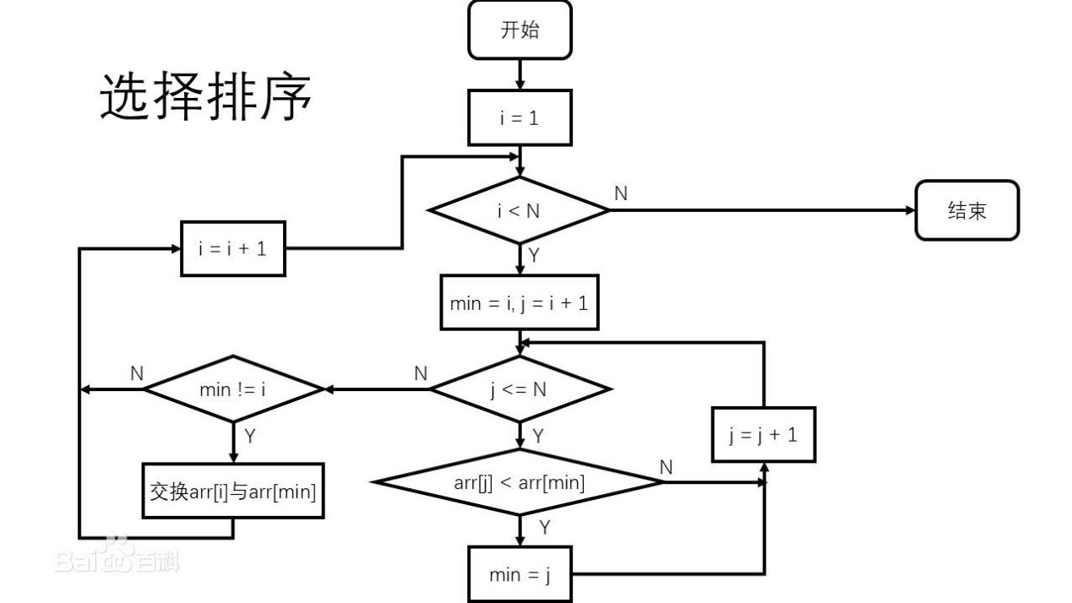

  - What’s the time complexity of merge sort? ____O(nlogn)____
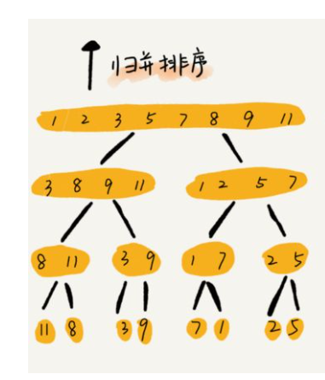

  - What’s the time complexity of quick sort? ___O(nlogn)_____

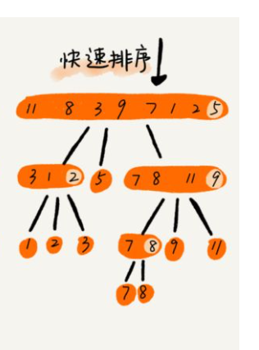

  - What sort is this? ___bubble sort 看最内层循环，如果前一个比后面的大，那就交换。因此这就是冒泡排序_____
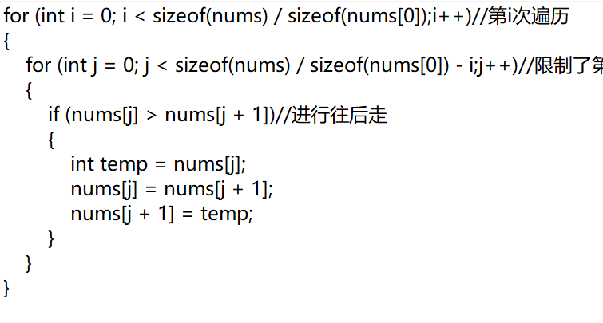

  - What sort is this? ____insert sort 每一步，总是把右边序列的第一个插入到左边序列的正确位置上，所以是插入排序____
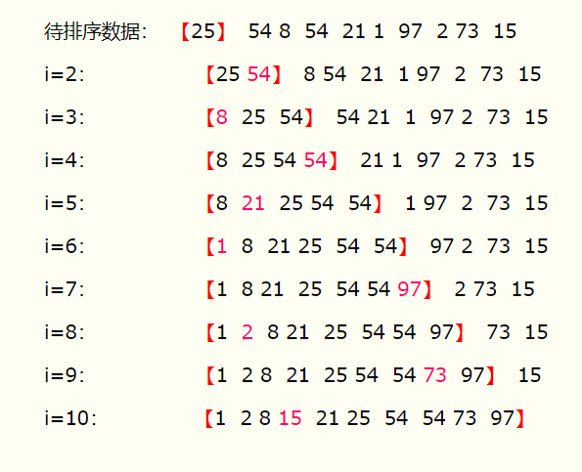

  - What sort is this? ____quick sort. 每次取一个基准，比基准小的放左边，比基准大的放在右边，然后再把左右两个小序列重复上面的过程，即再选基准、小的放左边，大的放右边。因此是快速排序。____
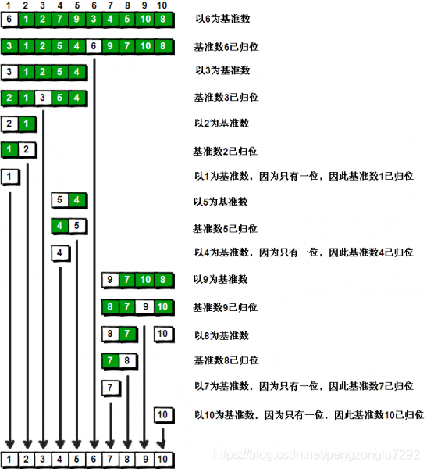

  - What’s the time complexity of heap sort?____O(nlogn)_堆排序是树型选择排序的改进，删去了正无穷，并且输出一个元素，剩下的元素就少一个。他本质逻辑还是和树选择排序一样，只是优化了一下，所以时间复杂度还是nlogn。如果你想从头思考的话，可以这样思考：把一个两边是堆但自己不是堆的东西变成堆，需要logn次（把最后一个元素放最上面，然后从上往下交换），一共要搞n次，所以是nlogn。最开始形成堆还要搞n-1次。但不改变最厉害的那个项。所以还是nlogn。___

  - What’s the time complexity of tournament sort? __nlogn______

  - What’s the time complexity of this? ___n^3_____
for (i=1; i<=n; i++)
for (j=1; j<=i; j++)
for (k=1; k<=j; k++)
x++;

  - What’s the time complexity of this? ____logn 二分查找，每次查找可以缩小一半的查找范围。查找范围从n缩小到1需要logn次，所以时间复杂度是logn____
int binary_search(int a[], int k, int len)
{
int left = 0;
int right = len - 1;
while (left <= right)
{
int mid = left + ((right - left) >> 2);
if (a[mid] == k)
{
return 1;
}
else if (a[mid] > k)
{
right = mid - 1;
}
else
{
left = mid + 1;
}
}
return NULL;
}

  - What’s the time complexity of this? ____nlogn 王紫若上课推过，倍乘系数然后加减消元。____
T(n) = 2T(n/2)+n
T(1)=0

  - What’s the time complexity of this? ____n. 这个就是等差数列求和____
T(n)=T(n-1)+1
T(1)=0

- Multiple-choice questions

  - Which of the following is a tree? _____a a是树，b是链表，c是栈___
A.
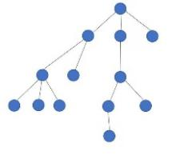
B.
C. 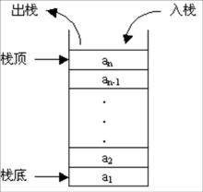
D. none of the above

  - Which one of the following is a heap ? ____a 堆就是任意一个节点，都比下面2个小或者大。____
- 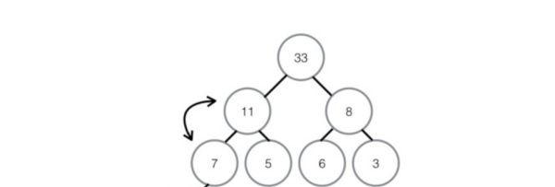
- 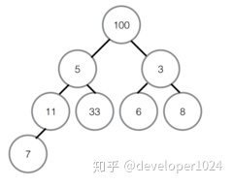
- 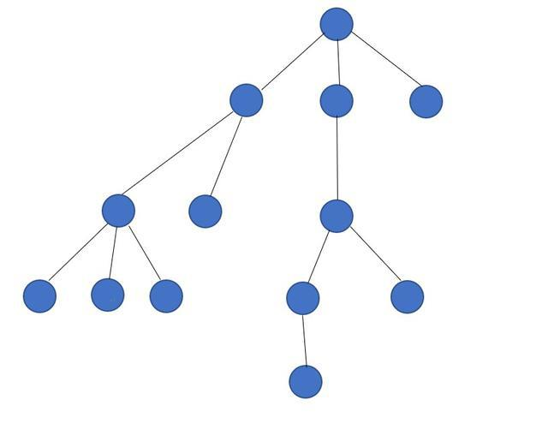
- none of those

  - What sort is this? __A__select sort 这题mix的命名很有误导性，应该命名成min，但不管他，我们主要看程序逻辑即可。从最内层j控制的那个循环开始看，其实就是找最小值。然后在看上一层循环，就是把最小值和i交换。所以是选择排序，每次把最小值选出来放前面。____
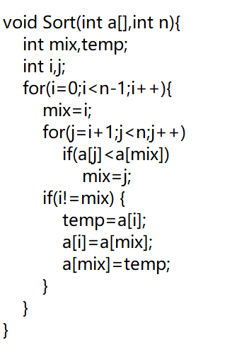
a) select sort
b) quick sort
c)insert sort
d)heap sort

  - Among 10000 elements,to get the first 100 elements in ascending order, which sort is the best? ____c 因为只需要找100个最小的数，a显然太麻烦了，b最多需要100n次1000000次，c再怎么拉跨也只在nlogn 10000log10000这个数量级上，怎么着也飞不到一百万上去，所以是c_ ___
    - bubble sort
    - select sort
    - heap sort
    - they are same

  - To get 2 smallest elements from 1000,which is the best way?__d 这次就是选择排序了，因为只取2个，最多也就2000次。你堆排序还得生成堆，生成堆的过程需要太多步骤了。就算只生成一次堆，也要1000log1000次，也比2000多了______
- Insert
- quick
- heap
- select

- True or false
- The algorithm is a description of the problem solving method and steps. ____t____
- In the chain storage structure of linear table, the two logically adjacent elements are not necessarily adjacent in physical position. ___t比如链表，一部分是数据，另一部分是下一个是谁。你d那部分指向谁，不代表你俩必须是邻居啊。比如我的下一个是周文睿，不代表我和周文睿就要物理接触。_____
- The advantage of sequential storage is that deletion efficiency is high. ____f 链表删除一个元素，只需要把上一个的指向下一个的指针改一下就行了，不用像数组那样一个个挪。Sequential storage指的是数组那种东西____
- The input sequence of a stack is: A.B.C.D, and the output sequence can be A.B.D .C. _____f 栈就是盒子，你先放的东西肯定最后拿出来，所以是dcba___
- The principle of stack operation data is first-in, first-out. ___f 栈就是只有一个口子的盒子，先进去的最后出来_____
- One single number be a heap. _t___显然可以。一个数也可以组成集合啊，没数还能组成集合呢。____

- Heap sort is better than tree sort. __t___堆排序是树排序的改进，前面说过了___
- A heap is a complete binary tree, but a complete binary tree may not be a heap.__t____yes 二叉树只要有2个叉就行了，但堆必须上面都比下面小，或者上面都比下面大__

- Heap sort is better than insert sort_____yes 堆排序毕竟是高级算法。___

- The following data structure is a binary tree? ___ 二叉树，每个点下面只能有2个孩子，当然如果只有一个孩子也可以看作有2个孩子。_____
- f
- t
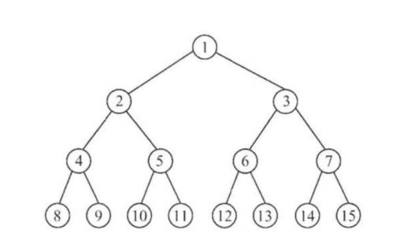

- Question and answer
- Design an algorithm to quickly find the median from an array.
(请设计一种算法，快速从一个数组中找到中位数)
先排序，然后取中间那个数。我觉得这应该是最快的了。所以才说排序算法是很多算法的基石，因为排序的速度取决于整个的速度。具体回答时需用伪代码描述算法细节。
- Design an algorithm to quickly find modes from an array.
(请设计一种算法，快速从一个数组中找到众数)
定义一个数组用来计每个数出现的次数。用for循环遍历一遍，然后把每个数出现的次数打到数组里去。然后找数组里的最大值。
或者还是排序，排好序看哪一段最长，哪个就是众数。具体回答时需用伪代码描述算法细节。
- Design an algorithm to solve the following problem: Given an array of non-empty integers, in which each element appears twice except for one element. Find the element that appears only once.
(请写出解决以下问题的算法的思路：给定一个非空整数数组，除了某个元素只出现一次以外，其余每个元素均出现两次。找出那个只出现了一次的元素)
哈哈，思路和上面一样的。还是2种思路，一个用数组计数，另一个排序之后找一下长度。具体回答时需用伪代码描述算法细节。
- Design an algorithm to solve the following problem: Given a string, verify that it is a palindrome string(A palindrome string is a string that reads the same for both forward and backward), considering only alphanumeric characters, regardless of letter case.
(请写出解决以下问题的算法的思路：给定一个字符串，验证它是否是回文串，只考虑字母和数字字符，可以忽略字母的大小写。
回文串就是正着读和倒着读一样的字符串。)
用for循环遍历，判断a[i] 是否恒等于 a[n-i-1].这种数字游戏怎么玩，就是把i取个特殊值，比如0，你看就是判断a[0]和a[n-1]是否相等，欸，这就对了。
还有一种方法，再搞个数组，用for循环倒着把字符串打到数组里，然后再比较这个数组和原来那个是不是一样的。具体回答时需用伪代码描述算法细节。
- Design an algorithm to solve the following problem: Given an array of numbers, write a function to move all zeros to the end of the array while preserving the relative order of the non-zero elements.
(请写出解决以下问题的算法的思路：给定一个元素为数字的数组，编写一个函数将所有 0 移动到数组的末尾，同时保持非零元素的相对顺序)
我想了一个不用在那一直挪动的办法，就是新搞一个数组，然后for循环遍历，再搞一个count，记录0的数量。如果是0就count++，不是0就读到新数组里。最后再往新数组里补0。具体回答时需用伪代码描述算法细节。
- Design an algorithm to solve the following problem: Given an array of size N, find the most of the elements. Most elements are those that occur more than n/2 in the array.
You can assume that the array is non-empty and that a given array always has most elements.
(请写出解决以下问题的算法的思路：给定一个大小为 n 的数组，找到其中的多数元素。多数元素是指在数组中出现次数 大于 n/2 的元素。
你可以假设数组是非空的，并且给定的数组总是存在多数元素)
和之前一样，可以先排序再找，也可以直接搞个数组记录出现的次数。具体回答时需用伪代码描述算法细节。
- Design an algorithm to solve the following problem: Given an array of length “n” in which only one number occurs an odd number of times and all the others an even number, how to find this number quickly with excellent space-time complexity
（请写出解决以下问题的算法的思路：给你一个长度为 n 的数组，其中只有一个数字出现了奇数次，其他均出现偶数次，问如何快速找到这个数字）
和之前一样，可以排序再找，也可以搞个数组记录一下最后再看哪个是奇数。具体回答时需用伪代码描述算法细节。
- Please list at least 2 sorting algorithms that use the idea of divide and conquer and explain why.
(请列举出至少2个用到了分治法思维的排序算法)
快速排序 归并排序
其实堆排序也用了。就是如果下面2个是堆，那自身可以形成堆。这个过程在最初形成堆里的过程就是先让下面形成堆，然后再让上一层形成堆，最终整个形成堆。就是把形成大堆分解成了让2个孩子形成堆最后再合成。所以是分治。

True/False
1、Coupling is a measure of how tightly two modules are bound to each other.（T）

Multiple choice（选择题）
- A stack is a structure.
- FIFO
- LIFO
- Both a and b
- None of the above
- A(n) list is also known as a queue.
- LIFO
- FIFO
- Unordered
- Ordered
- The pop operation of the stack. (push?)
- Deletes an item from the top
- Deletes an item from the bottom
- Inserts an item at the top
- Inserts an item at the bottom
- In a binary tree, each node has two subtrees.
- More than
- Less than
- At most
- At least
- For the following binary tree, if we use preorder traversal, the processing order is . (inorder, postorder, breadth-first?)
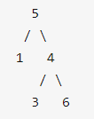
- 51436
- 15346
- 13645
- 51436
6． Which one of the following statements is TRUE?
a. Tight coupling is more desirable than loose coupling.
b. Data coupling is more desirable than content coupling.
c. Function cohesion is less desirable than procedural cohesion.
d. Sequential cohesion is less desirable than logical cohesion.

Open ended questions（开放题）
- Use an example to demonstrate depth-first traversal and breadth-first traversal of a binary tree.
- List some applications of stacks and queues.
- Use an example to explain the relationship between algorithms and data structures.
- Use examples to explain why there are so many types of data structures.
- Give daily examples (not necessarily in the field of computer science) of stacks, queues, linked list, trees, binary trees and graphs.
- Describe contexts outside of computer science in which the pointer concept occurs.
- Identify the data structures and procedures that might appear in an abstract data type representing an address book.
- Identify the data structures and procedures that might appear in an abstract data type representing a simple spacecraft in a video game.
- It is easy to transfer data and programs from one computer to another. Thus it is easy to transfer the knowledge held by one machine to many machines. In contrast, it sometimes takes a long time for a human to transfer knowledge to another human. For example, it takes time for a human to teach another human a new language. What implications could this contrast in knowledge transfer rate have if the capabilities of machines begin to challenge the capabilities of humans?
- The use of pointers allows related data to be linked in a computer’s memory in a manner reminiscent of the way many believe information is associated in the human mind. How are such links in a computer’s memory similar to links in a brain? How are they different? Is it ethical to attempt to build computers that more closely mimic the human mind?
- A spreadsheet is a table with rows and columns. Think about an Abstract Data Type spreadsheet. Which operations would you need to construct the table? Which operations would you need to manipulate the values in the table?
- If you are required to design a simple Word processor like Microsoft Word or WPS Word, what kind of data structures would you use and what operations/algorithms would you design? Why?
- Explain in your own words why loose coupling is more desirable than tight coupling. (Use examples to explain why loose coupling is more desirable.)
- Explain in your own words why function cohesion is more desirable than other cohesion. (Use examples to explain why function cohesion is more desirable.)
- Explain in your own words the relationship of algorithm design and software engineering.
- What are some of the basic ideas of modularity when it comes to software designing?

网络
TEST MATERIALS
填空题
- Match the word or acronym with the definition or the appropriate blank.
A.WAN B.LAN C.Gateway D.Bus topology E.Ethernet
- The industry standard for LANs. E
- A node that handles communication between its LAN and other networks. C
- A network that connects other networks. A
- Star topology is a B configuration
- Ethernet uses D .

- Match the word or acronym with the definition or the appropriate blank.
A.DSL B.TCP/IP C.UDP D.IP E.TCP F.Broadband
(7) A and voice communication can use the same phone line.
(8)DSL and cable modems are F connections.
(9)An Internet connection made using a digital signal on regular phone lines. A
(10)Network technologies that generally provide data transfer speeds greater than 25 Mbps. F
(11)The network protocol that breaks messages into packets at the destination,and take care of errors. E
(12)The suite of protocols and programs that supports low-level network communication. B
(13)An alternative to TCP that achieves higher transmission speeds. C
(14)Software that deals with the routing of packets. D
(15) E has more reliability than UDP.

- Match the protocol or standard with what it specifies or defines.
- SMTP B.FTP C.Telnet D.HTTP E.MIME type
(17)Log in to a remote computer system. C
(18)Transfer files to and from another computer. B
(19)Format of email attachments. E
(20)Exchange of World Wide Web documents. D

Mark the answers true or false as follows:
(21)A P2P network establishes a single portal through which communication is managed.（F）
(22)A port is a numeric designation that corresponds to a particular high-level protocol.（T）
(23)A firewall protects a local-area network from physical damage.（F）
(24)Each company can establish its own access control policy.（T）
(25)A TV cable company cannot also be an Internet service provider.（F）
(26)Some top-level domains are based on the country in which the registering organization is based.（T）
(27)There are now hundreds of top-level domains in the domain name system.（T）

选择题
- The biggest advantage of computer network is ( A )
A. file-sharing
B. enlarging capacity
C. efficient calculation
D. saving manpower

- Which of the following service is not provided by Internet ( D )
A. searching information
B. online games
C. telnet
D. multi-media making

- Which device is used in the chosen of data transfer paths when two different kinds of Internet connected with each other ( C )
A. Bridge
B. HUB
C. Router
D. Switch

- The communication between LANs obeys a certain kind of rules, which is called as ( D )
A. Configuration
B. Command
C. Asynchronous transmission
D. Protocol

- IP stands for ( A )
A. Internetwork protocol
B. TCP
C. Simple Network Management Protocol
D. Telnet

- Top-level domain “.com” shows that this domain belongs to ( D )
A. International organization
B. Education system
C. Government
D. Commercial Institution

- A B is a set of rules that controls the interaction of different devices in a network or internetwork.
A. model
B. protocol
C. dialog
D. synchronization point

- The A layer of the OSI model transmits a bit stream over a physical medium.
A. physical
B. data-link
C. network
D. transport

- The C layer of TCP/IP has functions similar to those of the application, presentation, and session layers of the OSI model.
A. transport
B. network
C. application
D. session

- What is the domain name in the email address kayla@pit.arc.nasa.gov?(C)
A. kayla
B. kayla@pit.arc.nasa.gov
C. pit.arc.nasa.gov
D. nasa.gov

- The transport layer protocol of TCP/IP is called D .
A. TCP
B. UDP
C. IP
D. A and B

- Both humans and C can be considered users of a database.
A. data
B. programming languages
C. applications
D. hardware

- Of the various database models, the C model is the most prevalent today.
A. hierarchical
B. network
C. relational
D. linked list

- The A database model arranges its data in the form of an inverted tree.
A. hierarchical
B. network
C. relational
D. linked list

- In database operations, a binary operator is applied to C relations(s) and creates an output of C relation(s).
A. one；one
B. one；two
C. two；one
D. two；two

- Which of the following is a unary operator in database operations?(D)
A. intersection
B. union
C. join
D. project

- D is a protocol for accessing and transferring documents on the WWW.
A. TELNET
B. FTP
C. SMTP
D. HTTP

问答题

- What is a computer network?
It’s a collection of computing devices that are connected in various ways to communicate and share resources.

- To what does the word node (host) refer?
Addressable device attached to a network.

- Describe the client/server model .
A distributed approach in which a client makes requests of a server and the server responds.

- What is a P2P network?
A decentralized approach that shares resources and responsibilities among many “peer” computer.

- Distinguish between the following LAN topologies: ring, star, and bus.How does the shape of the topology influence message flow through a LAN?
A ring topology connects all nodes in a closed loop on which messages travel in one direction.The nodes of a ring network pass along messages until they reach their destination.
A star topology centers on one node to which all others are connected and through which all message s are sent.
In a bus topology,all nodes are connnected to a single communication line that carries messages in both directions.The nodes on the bus check any message sent on the bus but ignore any that are not addressed to them.

- Messages sent across the Internet are divided into packets. What is a packet, and why are messages divided into them?
Packet is a unit of data sent across a network.
To improve the efficiency of transferring data over a shared communication line.

- Name three technologies for connecting a home computer to the Internet.
Phone modem,cable modem,,digital subscriber line(DSL)

- Explain the term packet switching.
The approach to network communication in which packets are individually routed to their destination,then reassembled.

- What problems arise due to packet switching?And how can they be solved？
A path may be blocked due to a down machine,and a router might send a packet along an alternative route.
A communication line may span a long distance,and the signal may be weaken.Repeaters are installed periodically along the line to strengthen and propagate the signal.

- What does the acronym of MAN represent?
Metropolitan-area network

- How is a hostname composed?
It consists of the computer name followed by the domain name.

- Why was the IPv6 protocol created for IP address?
The IPv4 strategy is limited in the number of unique computers(around four billion) it could identify.As Internet use increased,especially with the popularity of mobile computing devices such as smartphone and tablets,the supply of unique 4-byte IPv4 addresses dwindled.

- What is a top-level domain name（TLD）?
The last section of a domain name specifying the type of organization or its country of origin.
- An engineer notices that the data received by computers at the two ends of a bus LAN contain many errors. What do you think is the problem? What can be done to solve the problem?
An engineer notices that the data received by computers at the two ends of a bus LAN contain many errors.

- A small part of a bus LAN with 200 stations is damaged. How many other stations are affected by this damage?
In bus topology, when a station sends a frame to another computer, all computers receive the frame and check its destination address. So no computer is affected by this damage.
- A small part of a star LAN with 200 stations is damaged. How many other stations are affected by this damage?
If the core node station is in that 200 stations,all the stations will be affected by this damage.Otherwise,no computer is affected by this damage.
- A small part of a ring LAN with 200 stations is damaged. How many other stations are affected by this damage?
In the ring topology, a computer sends a frame to another computer by sending it to its neighbor. So, all the stations are affected by this damage.

- Change the following IP address from binary notation to dotted-decimal notation:
01111110 01100000 0111000 01111111
126.96.112.127

- You have relations A, B, and C as shown in the figure below. Show the resulting relation if you apply the following SQL statements:
select *
from B
where B2 = 216

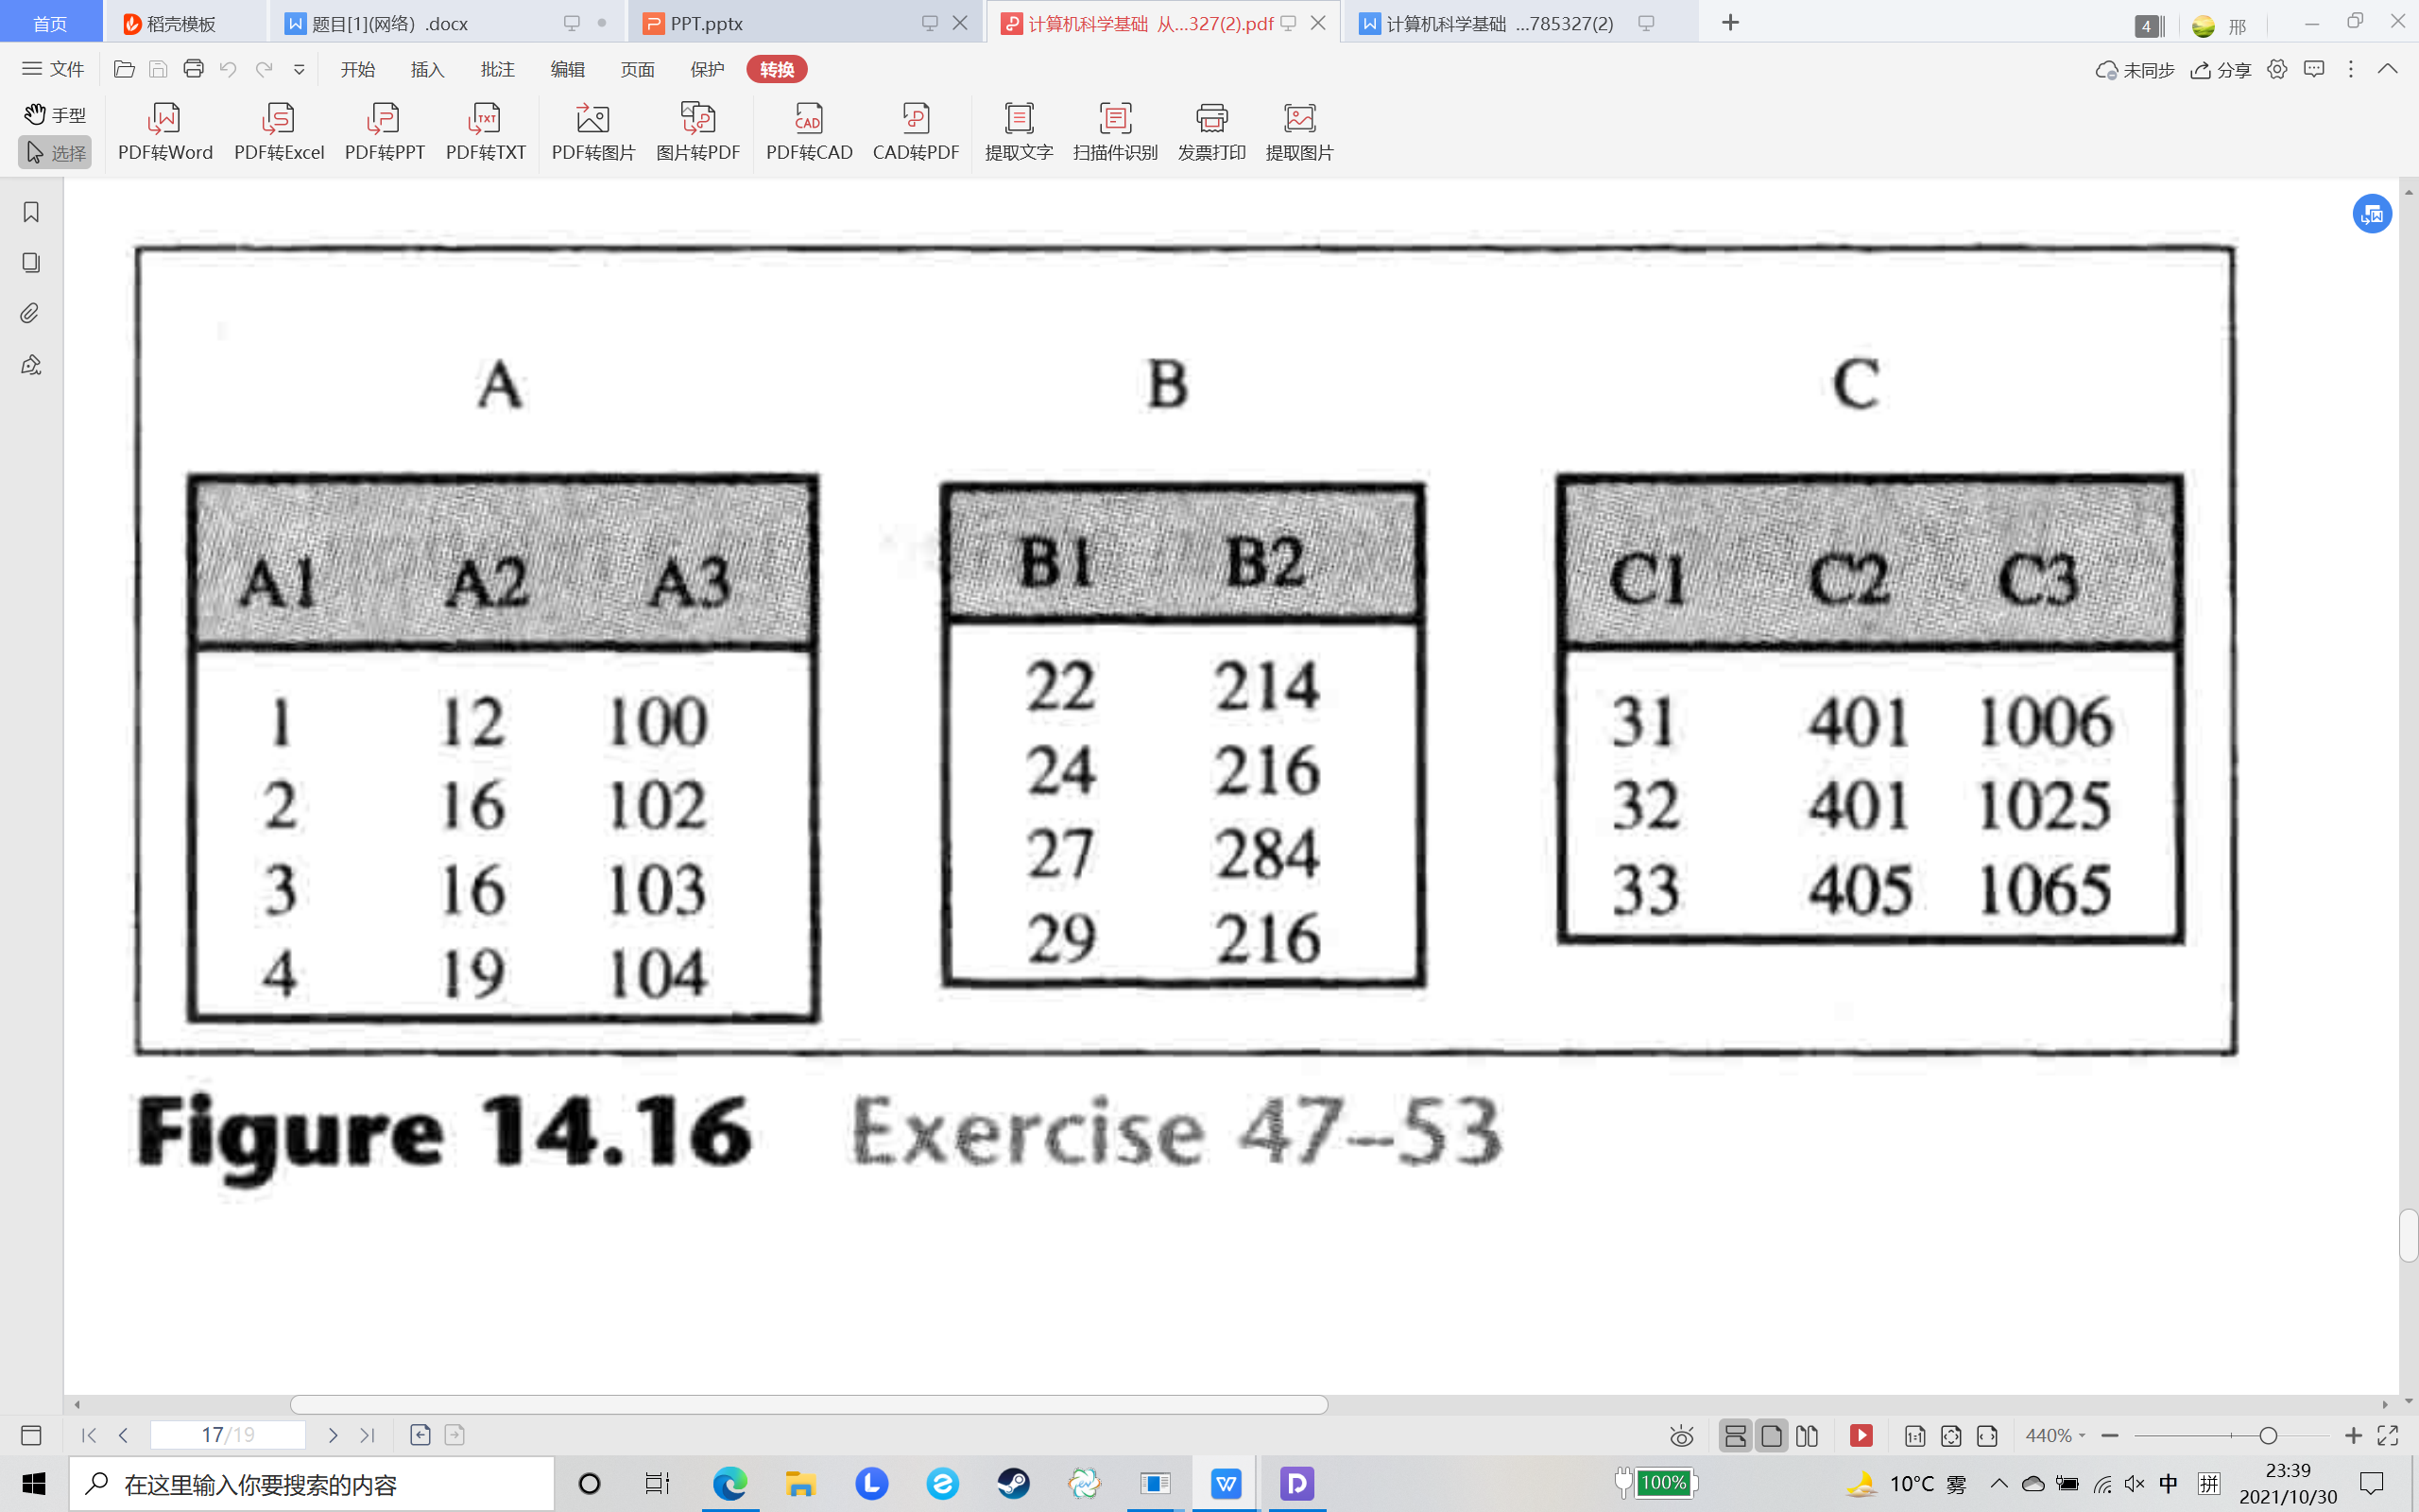
答案：

- Write down the corresponding SQL statement based on the following illustration.

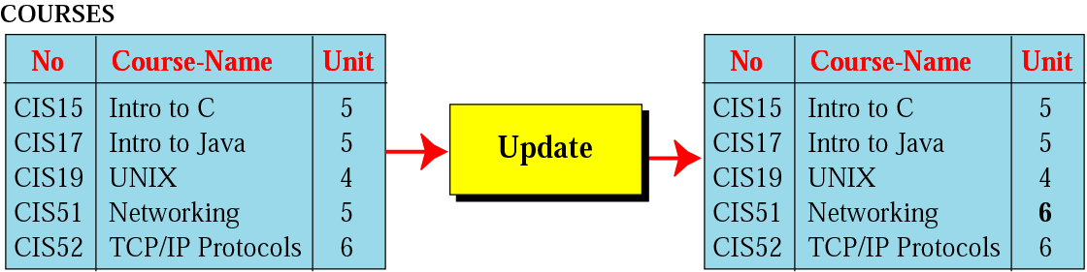update COURSES
set Unit=6
where No=CIS51 .

开放题
- Why can the Internet develop?
为什么互联网能发展起来？
角度一：一台电脑效率较低，互联网可以实现相互通信、资源共享、协同工作等基本功能以提高效率。
角度二：阿帕网的发展历史，互联网对于美国军事的重要性。
角度三：人类的活动范围变大，交流范围变大。通过互联网可以与世界交流
- If your computer can’t access the Internet,how will you deal with it?
如果一台 PC 机不能上网 ,那么你会怎么解决呢？
检查网卡连接；
检查 IP 地址设置是否正确，如果是动态获取地址，检查有没有获取到，获取的是否正确；
检查 PC 能否同本网络其它主机通讯；
检查 PC 能否与网关通讯；
检查 PC 的 DNS 设置是否正确；
检查能否和 DNS 通讯；
检查能否 PING 通服务器；
杀毒；

- What do you think of the view that "the Internet is a double-edged sword"
分析利弊，有理即可。
- Choose two or three from the following words,and talk about the connection between(among) these words.(Internet,Cloud computing,Big data,5G,Internet of things,AI)
基于对这些现进技术的了解，谈谈自己对这些技术的认识，以及对其之间关系的认识即可。
- What do you think of the social network apps like wechat,QQ,Facebook?Do you think that it makes people closer together or pushes people further apart?Why?

- Talk about your thoughts on the information cocoons.
Open ended questions：
- Explain what is happening behind the scenes when you connect your laptop via BIT campus network.
- Explain what is happening behind the scenes when you connect to Internet via 5G connection of your cell phone.
- What are some of the main ideas about computer networks?
- *Compare TCP/IP and OSI models.
- Why relational databases are more desirable than other database models?
- Compare big data and traditional databases.

